Disability Forum On Disability Services
In Spanish
April 12, 2019 11:00am to 2:00pm
Presented at:
Disability Resource Center
77 129th Infantry Drive
Joliet Illinois 60435
Information about resources and services will be provided and presented by various agencies including The ARC of Illinois, Family Resource Center on Disabilities and Disabilty Resource Center.
Bring your questions and concerns and join us in this open forum
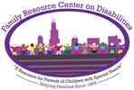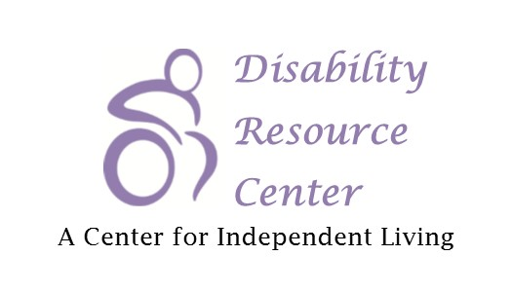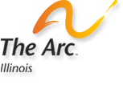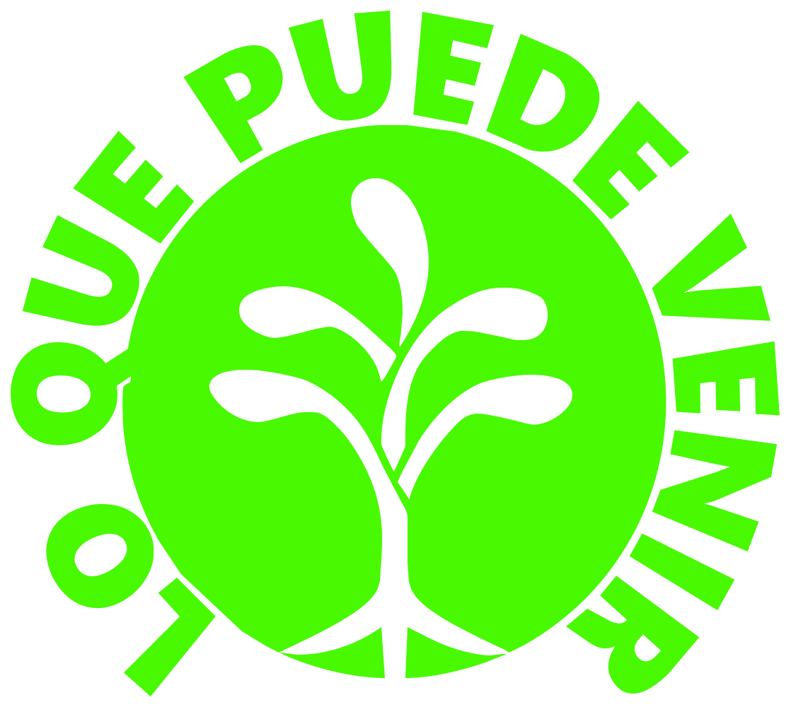

Sorry we can not offer separate child care. We can offer light refreshment
To register send a text to: 708-477-9519 or email: loquepuedevenir@gmail.org

