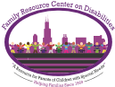
Family Resource Center on Disabilities
Parent Training and Information Center

TRANSITION- IEP and Delegation Rights
Presented by Maria Castillo Parent Trainer

In collaboration with:
CSS Family Support Center
&
Lo Que Puede Venir
Invitation to an information Session

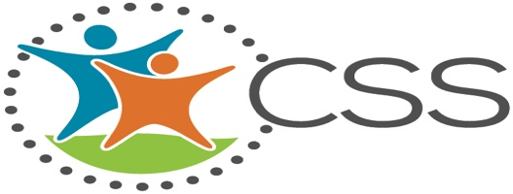

Transition-Guardianship and Alternatives
Presented by Consuelo Puente, Parent Trainer and Consultant

5416 W. 25 St.
Cicero, IL 60804

Monday, 24 and Tuesday 25, 2020
4:00pm to 6:00pm

Voice (312)939-3513 Fax: (312)854-8980
To Register Send Text to 312- 375-8136
or by email maria.castillo@frcd.org

